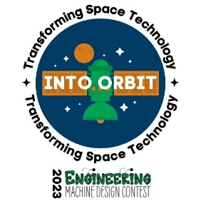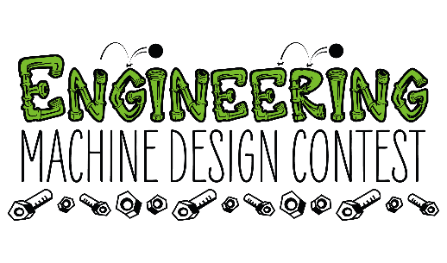
Engineering Machine Design Contest
Winona State University campus – Wednesday, March 20, 2024

Team Registration
School Click or tap here to enter text.
Division Choose an item.
Team Name Click or tap here to enter text.
Coach Contact Info
- Name Click or tap here to enter text.
- Email Address Click or tap here to enter text.
- Phone Number Click or tap here to enter text.

Team Members (up to 12 members)
1 Click or tap here to enter text.
2 Click or tap here to enter text.
3 Click or tap here to enter text.
4 Click or tap here to enter text.
5 Click or tap here to enter text.
6 Click or tap here to enter text.
7 Click or tap here to enter text.
8 Click or tap here to enter text.
9 Click or tap here to enter text.
10 Click or tap here to enter text.
11 Click or tap here to enter text.
12 Click or tap here to enter text.

Please email completed form to cose@winona.edu
Questions? Call 507.457.5585

